Short term plan: term 4
Checked:_______________

Unit: 2 Sports | Lesson 84
Teacher name: | U. Ussipbayeva
Date: | 01.04.2025
Grade: 5 «Ә» | Number present: 17 | absent:
Lesson title | Nouns: favourite things.
Learning objectives | 5.6.8.1 use a verb to be to talk about favourite things on a limited range of familiar general and curricular topics  5.2.4.1 understand the main points of supported extended talk on a range of general and curricular topics  5.3.2.1 ask simple questions to get information about a limited range of general topics.
Lesson objectives | Learners will be able to:  • Learn vocabulary to talk about favourite things.  • Practise talking about favourite things
Value links | Unity and solidarity
Plan

Stages / Time | Teachers’ actions | Students’ actions | Assessment criteria | Resources
Beginning of the lesson  5 min  3 min  7 min | Organization moment  1.Greeting.  Ask about the weather.  Warm-up  "Magic Ball" 🏀🎈  How to play?  The teacher throws a ball to a student and asks a question:  "How do you feel today?"  "How did your day start?"  "What makes you happy?"  The student answers and then throws the ball to another student.  Checking up the homework  Lead – In  The teacher sets the lesson objectives, letting students know what to anticipate from the lesson.  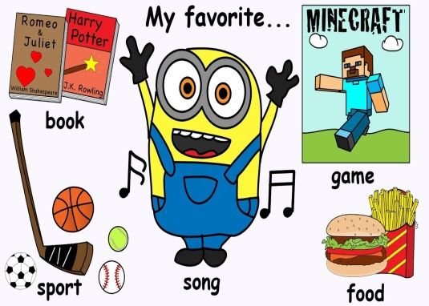 | Students' attention is drawn to the lesson.  Students answer the questions  Students answer the questions  Determines the topic and aim of the lesson  Students say different words from the picture | Formative Assessment    Descriptor:  -answer the questions  Total: 2 point  - Read and identify the main idea in the text. |   WORDWALL  Pictures  Presentation
Middle of the lesson  Presentation part.  25 min | Task 1.  Ex: 1 P:16  • Focus on the table and on the words in the left-hand column. Read through them with the class, checking for understanding.  • Students do the task in pairs. Circulate and monitor, helping out where necessary. Encourage students to match the words they recognize first  Differentiation:  «Verbal support» method is used to help Students use new words in the text.  Task 2. Listening  Prepare a short audio or read aloud sentences containing nouns. Example sentences:  1."I have a fluffy cat named Whiskers."  2."My favorite place to visit is the beach."  3."I love eating chocolate ice cream on hot days."  4."The elephant at the zoo is very big."  Task 3. Team work  - Divide the class into small groups (3–5 students per group).  Task:  Each group chooses a category of nouns (People, Places, Things, Animals).  They write or draw at least 10 favorite nouns under their category.  Decorate the poster creatively.  Task 4. Writing  1.My favorite (animal) is a _______.  2.I love going to (place) __________ because it is fun.  3.My favorite (thing) to eat is _____.  4. I like to play with my __________ (toy/object).  5.The best (person) in my life is __________.  6.At home, I have a pet ___(animal).  7.My school is called ______ (place).  8.On the weekend, I visit __________ (place) with my family.  9.My favorite sport is _____ (thing).  10.I have a big collection of (things).  Conclusion during the lesson some tasks differentiated by outcomes of the students and by their abilities. | Students match the words in columns A and B. make sentences  Answers:  1 Blue is a colour.  2 Angry Birds is a game.  3 A dog is an animal.  . 4 Basketball is a sport.  5 Jessie J is a singer  6 The Simpsons is a TV programme.  7 CSK Moscow is a team.  8 The Hobbit is a film  9 Angelina Jolie is a film star.  Students listen carefully and write down the nouns they hear.  Answers:  Students’ own answers  Each group presents their poster to the class and explains their choices.  Other groups ask questions or add more nouns to their category.  Students complete the sentences  Answers:  Cat, dog etc.  Zoo, school, park etc.  Play station, computer  Father, mother etc. | Descriptor:  - match the words in columns  Total: 2 point  Descriptor:  - write down the nouns  Total: 2 point  Descriptor:  - present the poster  Total: 2 point  Descriptor:  - complete the sentences  Total: 2 point  Total point :10 | Student’s book    CD  Large sheets of paper  Markers, colored pencils  Worksheets
End of the lesson  5 min | FEEDBACK  - – "I understood everything!"  - – "I understood some things."  - – "I need more help with nouns."  Each student must write one sentence using a noun before leaving. Example:  1."My favorite food is pizza."  2."I love my pet cat."  3."The park is a fun place to play."  Giving homework: To write about favourite things | Students provide feedback on what they have learned at the lesson.  Students read their sentence aloud | Well done!  Brilliant!  Good job! |   

